[MyEducator Home Page](https://www.myeducator.com/)

* [BMIS 441 02: Database Manag...](https://app.myeducator.com/course/activity/617eba/2776598404347756545/#)
* [Contents](https://app.myeducator.com/course/activity/617eba/2776598404347756545/#)
* Course
* Nathan Yoon

# **BMIS 441 02: Database Management [Fall 2021]**

## **SQL Assignment #9-Group By & Aggregate Function Queries**

For each information request below, formulate a single SQL query to produce the required information. 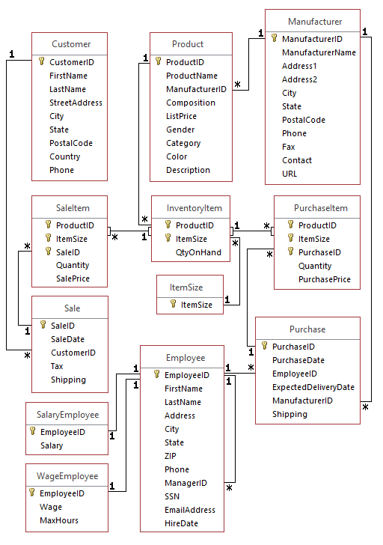

| Due Date: | Oct 31 at 23:59 |
| --- | --- |
| Points: | 100 |

Graded on Nov 09 at 15:30

Your Submission:

| Submission Score: | 100 / 100 (100.00%) |
| --- | --- |
| Grade Time: | Nov 09 at 15:30 |
|  |  |

1. How many products does Redcat have from Manufacturer 154? (Name the column NumberProducts.)
2. SELECT COUNT(ProductID) AS 'NumberProducts'
3. FROM Product
4. WHERE ManufacturerID = 154;

**FEEDBACK**10 / 10 (100.0%)

1. What is the average shipping cost on a sale? (Name the column AverageShipping). Also use the Round function to two decimal places for currency, i.e. round ( .. , 2) .
2. SELECT ROUND(AVG(Shipping),2) AS 'AverageShipping'
3. FROM Sale;

**FEEDBACK**10 / 10 (100.0%)

1. What is the largest dollar amount (SalePrice times Quantity) for a sale item that was ever made? Name it LargestItemSale.
2. SELECT MAX(SalePrice * Quantity) AS 'LargestItemSale'
3. FROM SaleItem;

**FEEDBACK**10 / 10 (100.0%)

1. What is the average shipping cost on sales made in the month of June? Name the column AverageShipping. Also use the Round function to two decimal places for currency, i.e. round ( ... , 2) .
2. SELECT ROUND(AVG(Shipping),2) AS 'AverageShipping'
3. FROM Sale
4. WHERE MONTH(SaleDate) = 6;

**FEEDBACK**10 / 10 (100.0%)

1. For each category and color, what is the maximum list price of men's shoes (Gender = 'M') in that category and color? Sort by Category. Name the column MaximumPrice. Only show category, color, and maximum price.
2. SELECT Category, Color, MAX(ListPrice) AS 'MaximumPrice'
3. FROM Product
4. WHERE Gender= 'M'
5. GROUP BY Category, Color
6. ORDER BY Category;

**FEEDBACK**10 / 10 (100.0%)

1. For each manufacturer (ID only) what is the highest price for any product in each category? Show ManufacturerID, category, and the highest price. Order it by Manufacturer. Name the column MaxPrice.
2. SELECT ManufacturerID, Category, MAX(ListPrice) AS 'MaxPrice'
3. FROM Product
4. GROUP BY ManufacturerID, Category
5. ORDER BY ManufacturerID;

**FEEDBACK**10 / 10 (100.0%)

1. Display the number of products in each category as well as the average list price of those products.
2. SELECT Category, COUNT(Category) AS 'NumberOfCategoryProducts', AVG(ListPrice) AS 'AverageListPrice'
3. FROM Product
4. GROUP BY Category;

**FEEDBACK**10 / 10 (100.0%)

1. Modify the query for question 7 to display only those products whose color is ‘Black’.
2. SELECT Category, Color, COUNT(Category) AS 'NumberOfCategoryProducts', AVG(ListPrice) AS 'AverageListPrice'
3. FROM Product
4. WHERE Color = 'Black'
5. GROUP BY Category, Color;

**FEEDBACK**10 / 10 (100.0%)

1. Which sale has the highested total amount(Quantity*SalePrice)? Group by SaleID and only list the SaleID and the highested total amount over $50. Sort the records by SaleID in a descending order.
2. SELECT MAX(Quantity * SalePrice) AS 'HighestTotalAmount', SaleID
3. FROM SaleItem
4. GROUP BY SaleID
5. HAVING HighestTotalAmount > 50
6. ORDER BY SaleID DESC;

**FEEDBACK**10 / 10 (100.0%)

1. List managerID and the number of the employees living in the city of Los Angeles or San Francisco or Irvine by ManagerID. Only show those who manage more than 1 employee. Order by managerID in an ascending order.
2. SELECT ManagerID, COUNT(EmployeeID) AS 'NumberOfEmployees'
3. FROM Employee
4. WHERE City IN('Los Angeles', 'San Francisco', 'Irvine')
5. GROUP BY ManagerID
6. HAVING NumberOfEmployees > 1
7. ORDER BY ManagerID;

**FEEDBACK**10 / 10 (100.0%)

Copyright © 2022 MyEducator. All rights reserved.

[Need Help?](https://myeducator.freshdesk.com/support/home)